Task 2
Data Visualization
- Missing values visualization
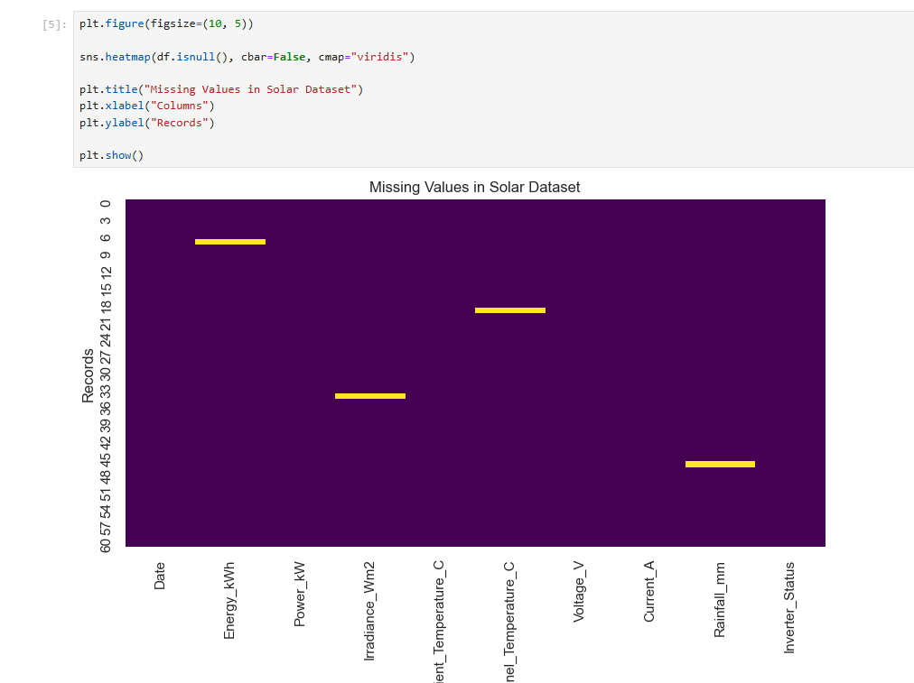

2.Energy generation distribution
This histogram shows how frequently different energy-generation values occur.
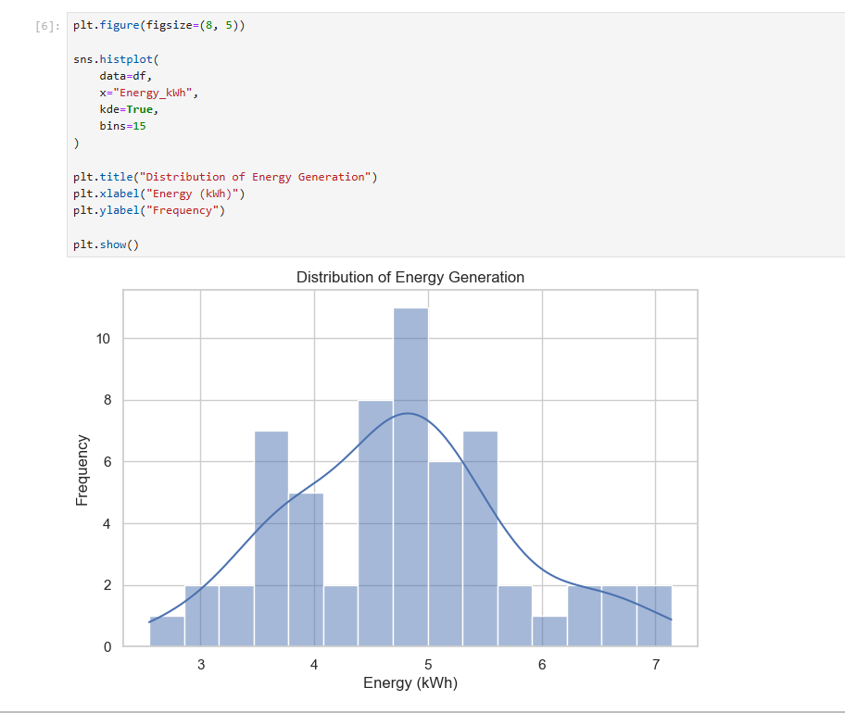

3. Energy generation over time
This helps identify changes in energy production across dates.
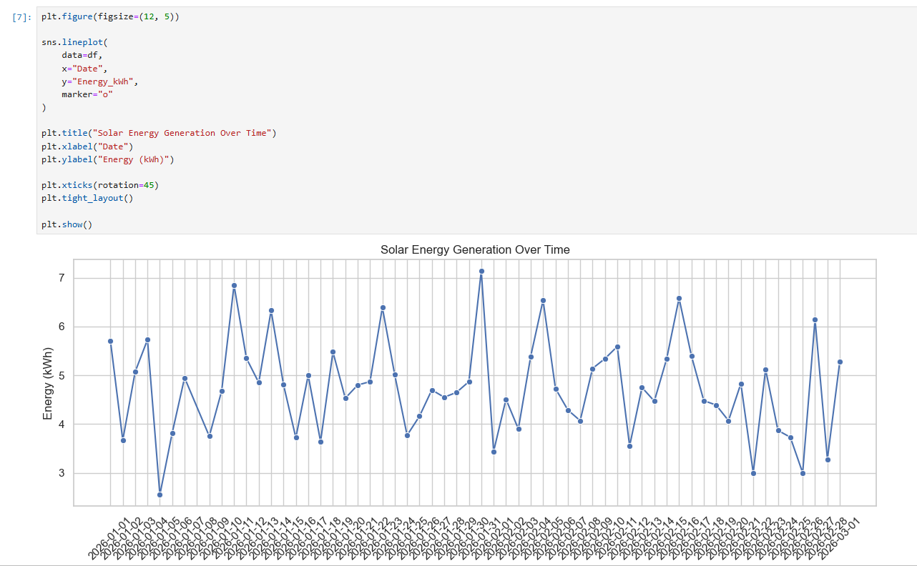

4. Solar irradiance vs energy generation
This helps investigate whether higher sunlight intensity is associated with greater energy production.
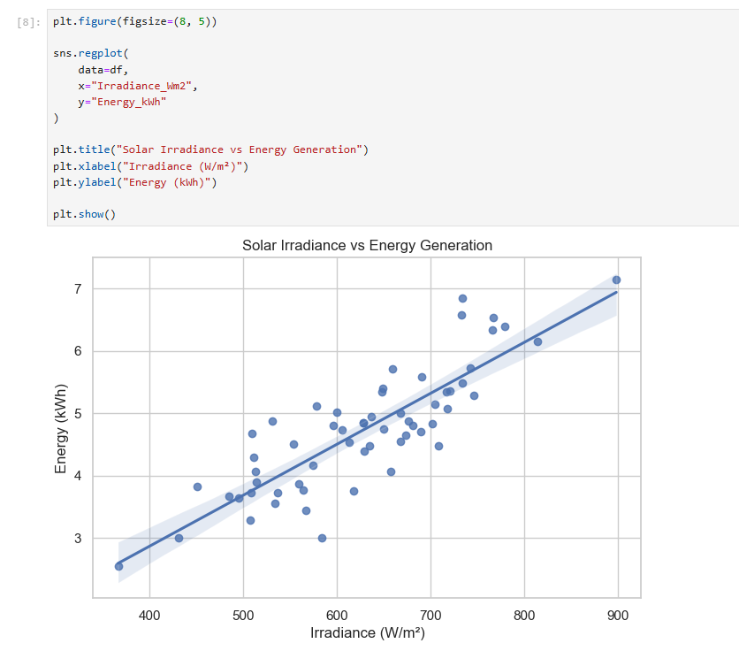

5. Ambient temperature vs energy generation
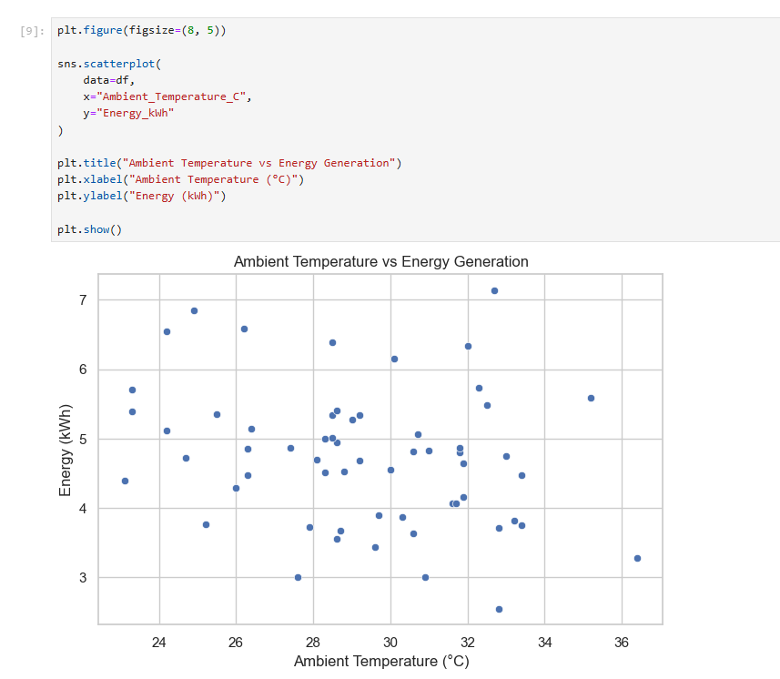

6.Voltage and current distribution


